Is Smart factory and Industry 4.0 one and the same?

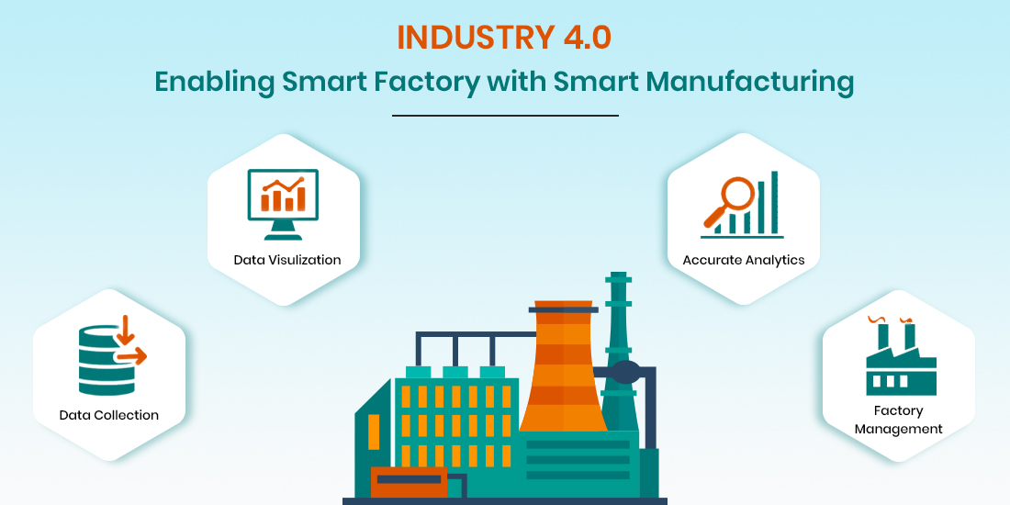

Is smart production the same as industry 4.0 ? How are the concept of smart factory and Industry 4.0 related? We often stumble upon such types of questions which leave us thinking and in this article we are going to resolve all such doubts.

Topics covered

~Smart factory vs Industry 4.0

~Technologies of Industry 4.0 in Smart Factory

* Internet of Things(IoT)
* Cloud Computing
* Big Data Analytics
* Augmented Reality
* Cyber Security

~The four levels of a smart factory evolution

~The benefits of Smart Factory

First things first, smart factory in a way is a manufacturing solution and key fabricate of Industry 4.0 . Yes its synonymous with Industry 4.0 but not the exact same .

To understand the above statements deeply we first need to know what is Smart Factory?

The Smart Factory is a concept for expressing the end goal of digitization in manufacturing. They gather and share data through interconnected devices that can then be used by devices to not only improve manufacturing processes, make their operations flexible ,adaptable and optimizable but also meet new demands.

Industry 4.0 is built on top of internet service, which is further built upon Smart factories that are in turn built upon Cyber Physical Systems that uses IoT technologies and infrastructure for its purposes.

(Note: The following picture is from google , please don’t use this , something created keeping this in mind would do)

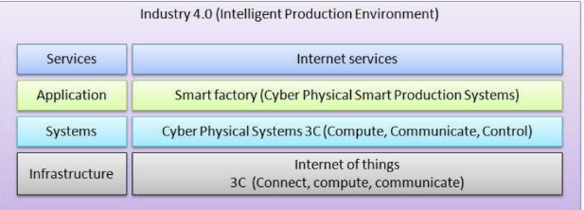

TECHNOLOGIES OF INDUSTRY 4.0 IN SMART FACTORY

Smart factories practice smart manufacturing which is the maximized application of technologies emerging from Industry 4.0. Let us have a look at a combination of diverse Industry 4.0 technologies that contribute in the optimization of smart manufacturing .

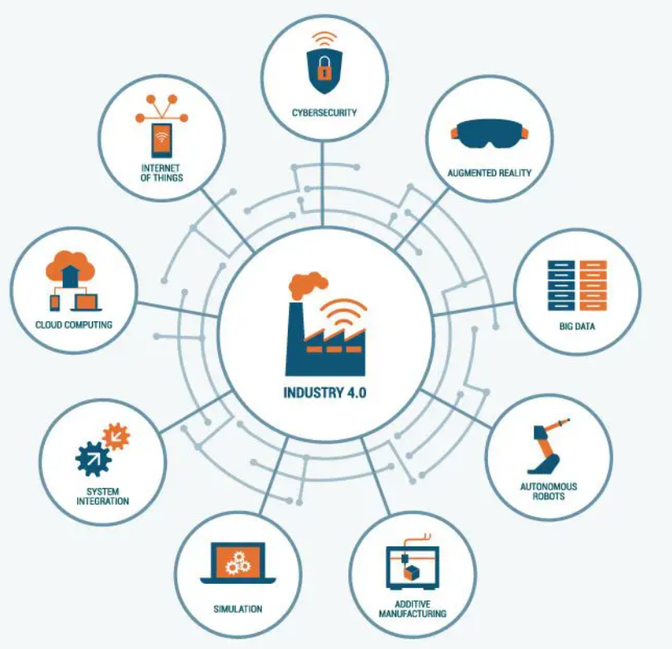

1. Internet of Things(IoT)- Internet of things refers to a system of inter-connected systems or objects that are capable of collecting and transferring data over a wireless network without human intervention. IoT enables automation like never before . Machines make split second decisions based on tremendous amount of data which facilitates in product engineering and management.
2. Cloud Computing- Cloud computing facilitates smart factories to store data on remote servers ,process and share it , all on the click of a button. It provides for greater flexibility and low cost.
3. Big Data Analytics- Big data is one of the most powerful ways to gain insights about the efficiency of production process, the areas that need to be focused upon and run predictive quality assurance with increased accuracy. Its analysis helps organizations to harness data and optimize their opportunities. Not only does it improve operations and customer service but can also reduce costs dramatically.
4. Augmented Reality-The key role of Augmented reality is to revolutionize the way information is accessed , used and exchanged. AR and VR have the potential to maximize our perceptive experience and contribute towards transforming the industrial production processes.
5. Cyber Security- Industry 4.0 does lead to increased productivity and many other advantages but it also consists of interconnected heterogenous networks which leaves us exposed to increased cyber risks. And thus to reduce this risk , manufacturers implement cybersecurity solutions and use platforms that automatically assess loop holes and exposures for devices , empowering them with complete Visibility into IT and OT networks.

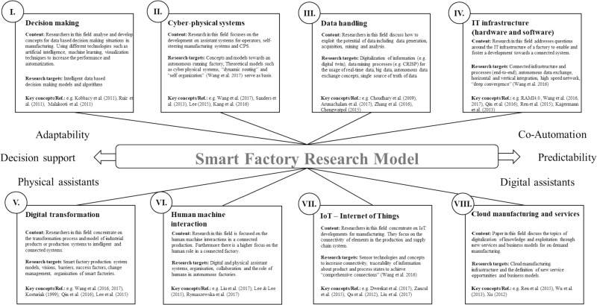

The Four Levels of Smart Factory Evolution

For many organizations , the prospect of transforming into a smart factory can be overwhelming at first . It is critical to understand that leveraging data is the key to a smart factory but trying to achieve the ultimate goal way too quickly can be a major setback that can lead manufacturers back to square one , in addition to the wastage of time and money.

Hence it becomes to important to have insights about the four key stages that result in real-time insights and data-driven decision making .

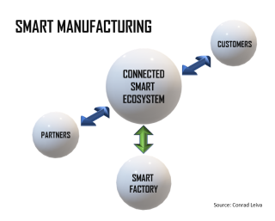

* LEVEL ONE :: Connected Data

The rudimentary step to enabling a Smart factory is to connect the available data and integrate heterogenous sources into a solitary(single) source of truth that can gather and track production data continuously. Problem solving becomes much effortless if there is a data repository that can be accessed at all and any time. Besides, a connected data infrastructure helps in remote as well as real-time monitoring of the factory floor. This saves time of engineers which they can then invest in optimizing , waste reduction and quality improvement.

* LEVEL TWO :: Predictive Analytics

To move to the this level , manufacturers need to enhance machine learning so as to enable predictive analytics.

At level two , emphasis is laid on adding new technologies like artificial intelligence and machine learning to predict and prevent issues on the factory floor.

More importance is given to proactive analysis and improvements rather than just reactive problem solving. Predictive analysis helps engineers to take precautions to avoid significant downtime or quality failures. Level two combined with level one infrastructure produces a smart system that predicts and alerts about failures accurately and much beforehand so that the person concerned can proactively take necessary actions. Real time alerts provide valuable information so that factory personnel do not have to analysis process manually to find solution to solving production issues.

However , implementing a new data architecture , requires a significant amount of time and effort and to do this , evaluation needs to be done about the system concerned and then accordingly select a scalable solution and the right providers and partners. Manufacturers should transit from level one to two as soon as possible in order to avoid risking millions of dollars in lost production output from unplanned downtime each day.

* LEVEL THREE :: Prescriptive Analytics

Predictive analytics is an integral part of the smart factory evolution which helps to minimize downtime and optimize production capabilities to a great extent.

Smart factory uses data collected from sensors to provide insights on the production process that is currently underway. However, raw data cannot be used to plan effective actions for the future but specific information extracted from data can .

In predictive analytics , data extracted from existing data can be used to forecast possible future outcomes based on recognizing usage patterns. Prescriptive analytics is based on the idea of analyzing historical production data and segregating the variables and product settings that contribute to your most and least profitable runs. It not only gives engineers the prospect to optimize outputs without compromising on the product quality but also helps manufacturers eradicate inefficiencies and reduce waste production.

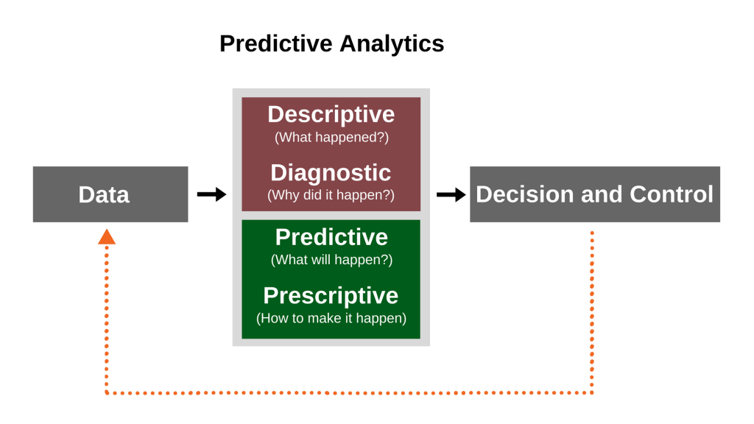

* LEVEL FOUR :: AI-Driven Automation

Level four is all about deploying the recommendations obtained by analyzing the manufacturing data. Artificial Intelligence driven automation is assured to transform global manufacturing. AI has become an essential tool that helps manufacturers inject next-level automation into their processes. Creating machine learning models that work on real time data and identify methods of optimization, then generate and send recommendations to another machine

reduces the execution time on an insight discovered by the system to a minimal. However , achieving level four requires large and validated datasets to be able to assess the impacts of a production change accurately. If implemented and accepted successfully, it reaps tremendous benefits to manufacturers.

BENEFITS OF SMART FACTORY

Smart factory provides for flexibility, scalability and agility as some prominent benefits to the industry. They reduce downtime , lower costs and minimize misplace or underused production. Not only does it result in drastically increased productivity but also performs more predictive and advanced system maintenance. Digitalization and smart machines transform the way we work and naturally leads to change in customer demands. Smart factory is an excellent solution to meet those demands with personalization . Customization allows people to interact with company directly. By promoting their customer experience , organizations scale their services and implement Industry 4.0 better.